H1 Statistical Analysis:
Following the extraction, cleaning, and preprocessing of the financial data through SQL, statistical analysis was performed to examine the relationships among the selected financial ratios for the fourteen sectors of the Pakistan Stock Exchange (PSX). Since the an objective of this study was to investigate the degree of association among the financial indicators, so correlation analysis was employed as the principal statistical technique. This analysis provides an overview of the strength and direction of the linear relationships between variables and serves as a preliminary step in understanding the interaction among profitability, liquidity, leverage, efficiency, and firm size measures before drawing further financial interpretations.
H2 Tools for Statistical Analysis:
The correlation analysis was conducted using the R programming language within the RStudio integrated development environment (IDE). R was selected due to its extensive statistical capabilities, reproducibility, and efficient handling of financial datasets. The analysis involved computing Pearson's correlation coefficients among the selected financial ratios and visualizing the resulting correlation matrix using appropriate statistical packages. Given figure presents the R script used to generate the correlation matrix and perform the statistical analysis.
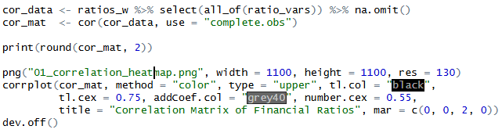
H2 Correlation Matrix and its interpretation:
The correlation matrix reveals several noteworthy relationships among the selected financial ratios across the fourteen PSX sectors. Strong positive correlations are observed among Net Profit Margin, Gross Profit Margin, and Operating Margin, indicating that these variables consistently measure similar aspects of corporate profitability. Return on Assets (ROA) demonstrates moderate positive associations with profitability measures, whereas Return on Equity (ROE) exhibits relatively weak correlations, suggesting that it is influenced by additional factors such as financial leverage. Furthermore, leverage ratios, particularly the liabilities-to-assets ratio, display negative relationships with profitability indicators, implying that firms with higher debt levels generally tend to achieve lower profitability. Likewise, the Current Ratio and Quick Ratio are highly positively correlated, reflecting their similar role in assessing short-term liquidity.
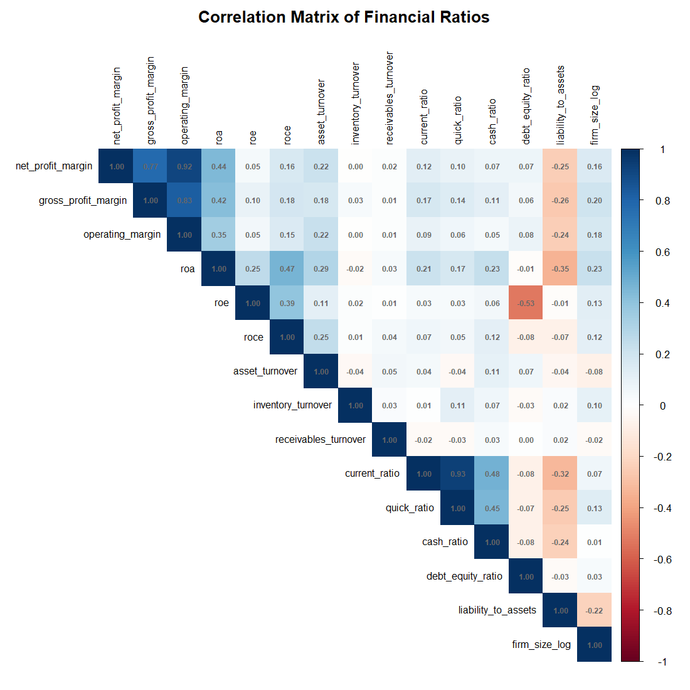
Conversely, Inventory Turnover and Receivables Turnover exhibit only weak correlations with the remaining financial ratios, indicating that operational efficiency is largely independent of profitability, leverage, and liquidity within the sampled firms. Firm size, measured as the natural logarithm of total assets, shows weak positive relationships with profitability and a weak negative association with leverage. Overall, the correlation analysis indicates expected financial relationships while revealing no evidence of severe multicollinearity among the variables, thereby supporting the suitability of the dataset for subsequent financial interpretation.

